CHALLENGE ON GIT AND GITHUB
- Resolve Merge Conflicts
- Firstly know the available branches in repository by the command -> git branch –list
- Then create a file file.txt with the content -> vi file.txt
- Then add that file -> git add .
- Then commit the file -> git commit -m “file.txt file is added”

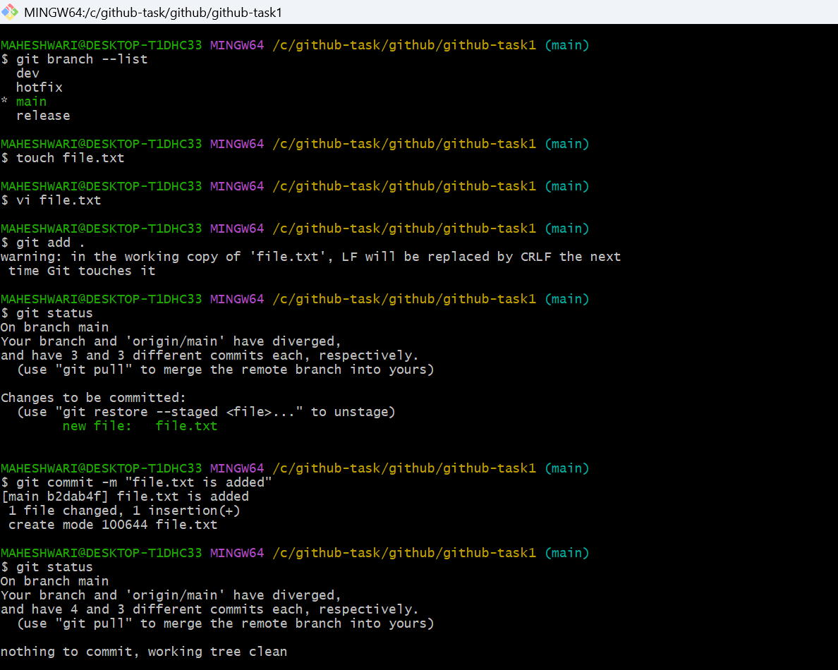
- Then switch to other branch by command -> git checkout dev
- In the present branch create a file with the same name -> vi file.txt
- Then add that file -> git add .
- Then commit the file -> git commit -m “file.txt file is added”
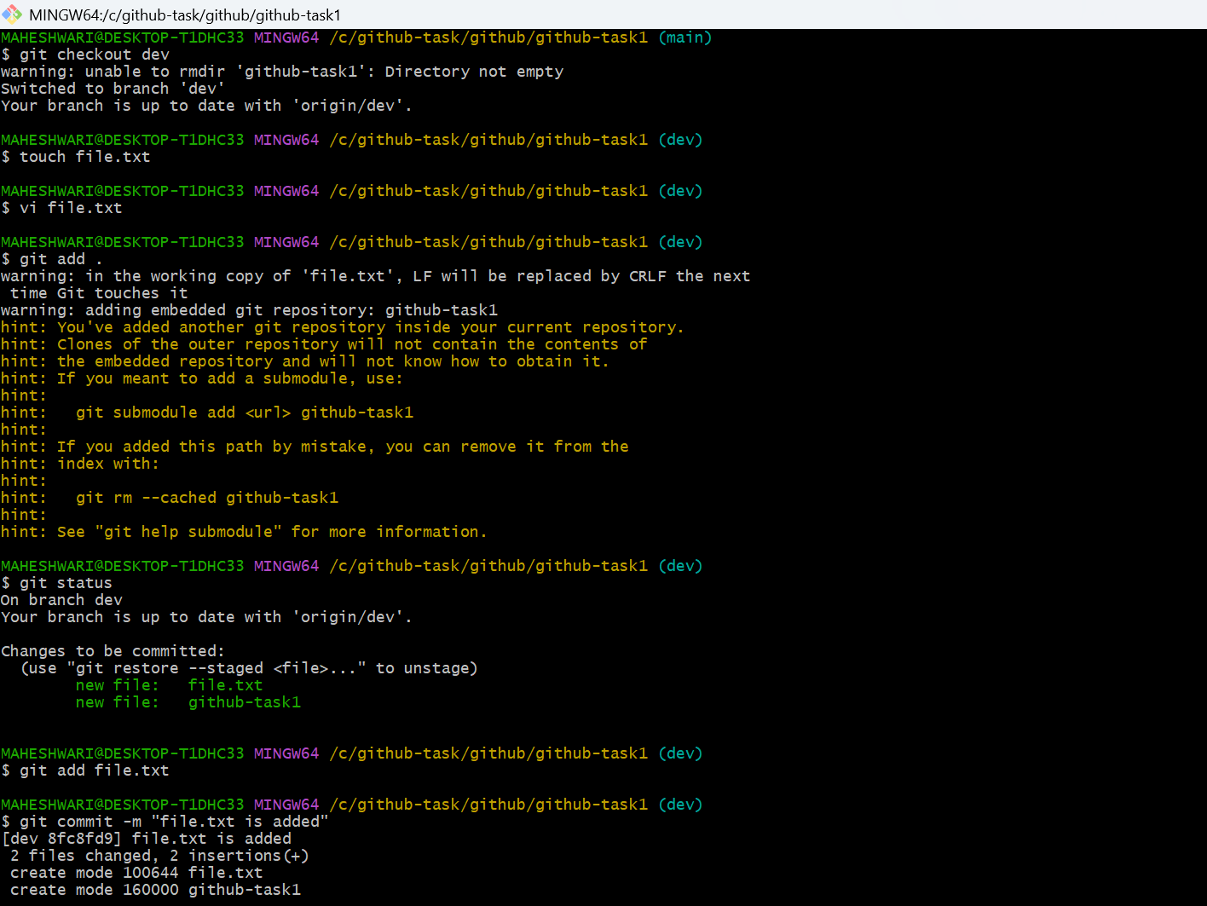
- Now switch to the branch where we have created the file first
- Here merge the file from this branch -> git merge dev
- Now we can see a merge conflict
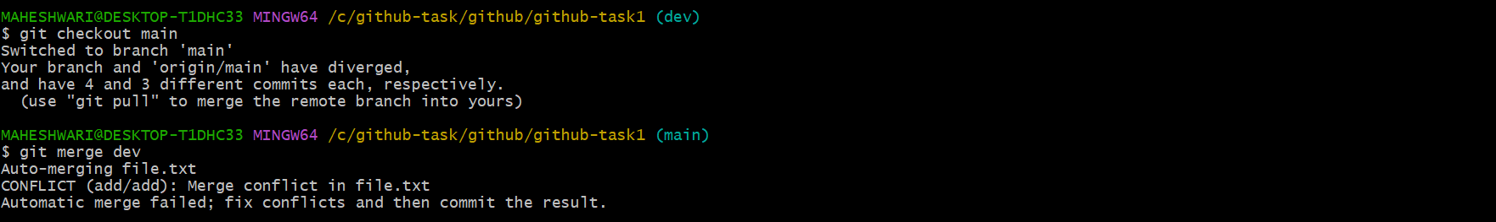
- Now we can resolve this merge conflict by editing the file file.txt -> vi file.txt
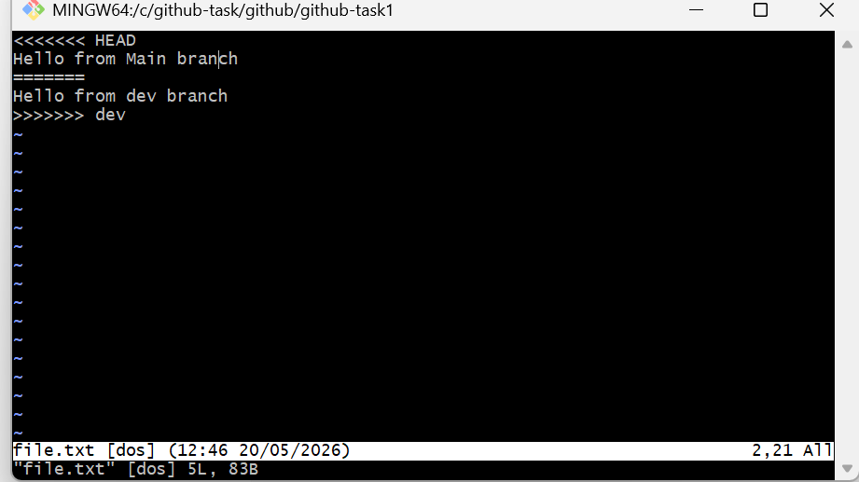
- remove the HEAD, separator and dev
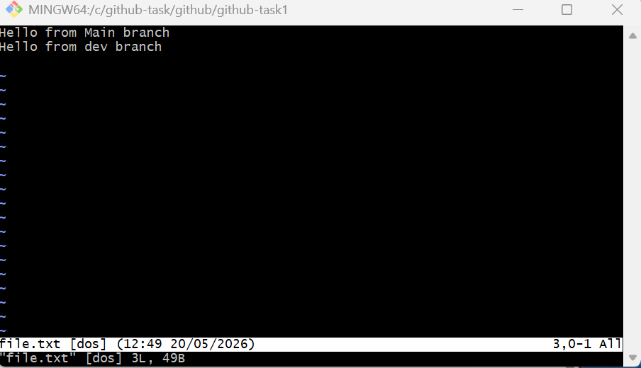
- then add that change by the command -> git add.
- Then commit that change by the command -> git commit -m “resolved the merge conflict”
- By this process the merge conflict will automatically resolve
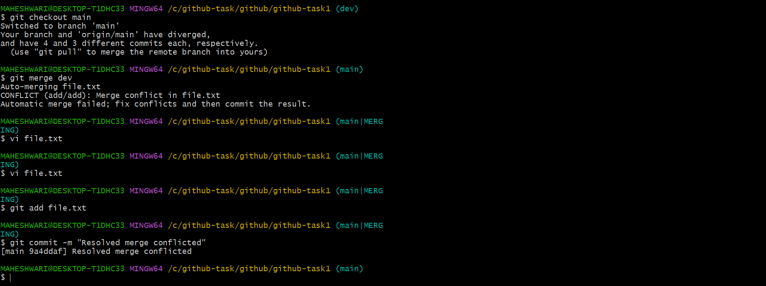

- Recover Deleted Branch
- Firstly we have to check the available branches -> git branch –list
- Then create a branch name feature -> git checkout -b feature
- By this command we can create a feature branch and switch to that branch also.
- Then create a file -> vi feature.txt and add that file git add .
- Then commit that file -> git commit -m “feature.txt file is added”
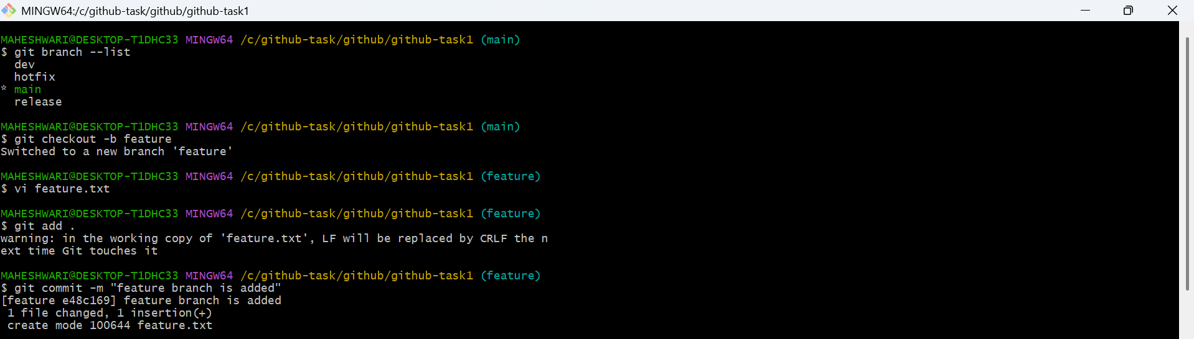
- To verify that feature branch is created or not switch to the main branch and list the branches -> git branch –list
- To delete that created branch -> git branch -d feature
- If any error is created to delete the branch then delete it forcefully -> git branch -D feature
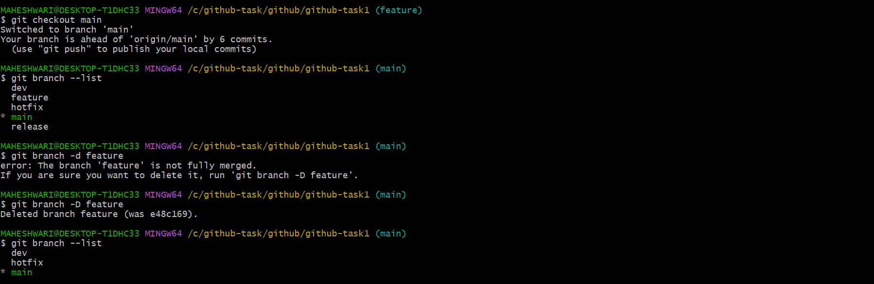
- To recover the deleted branch feature we should have commit id of feature branch created commit and to get that commit id
->git reflog
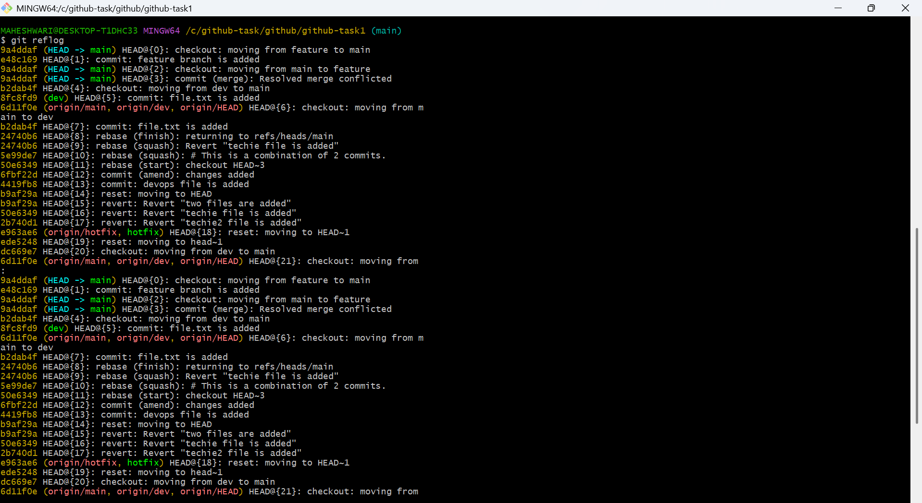
- Then with the commit id we can recover it by the command ->
git checkout -b feature commitid
- By the above command we will switch to that deleted branch
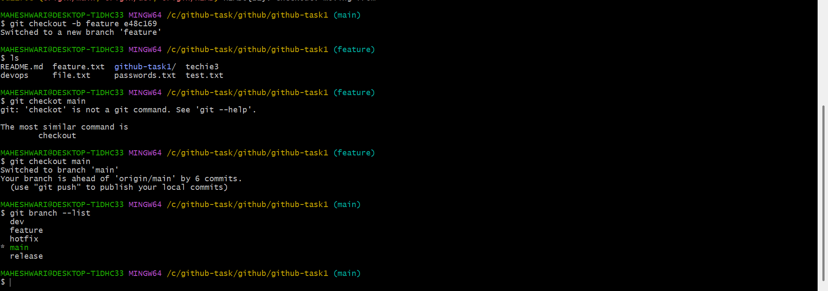

- Undo Wrong Push
- Get the commits in one line we can use the command -> git log –oneline
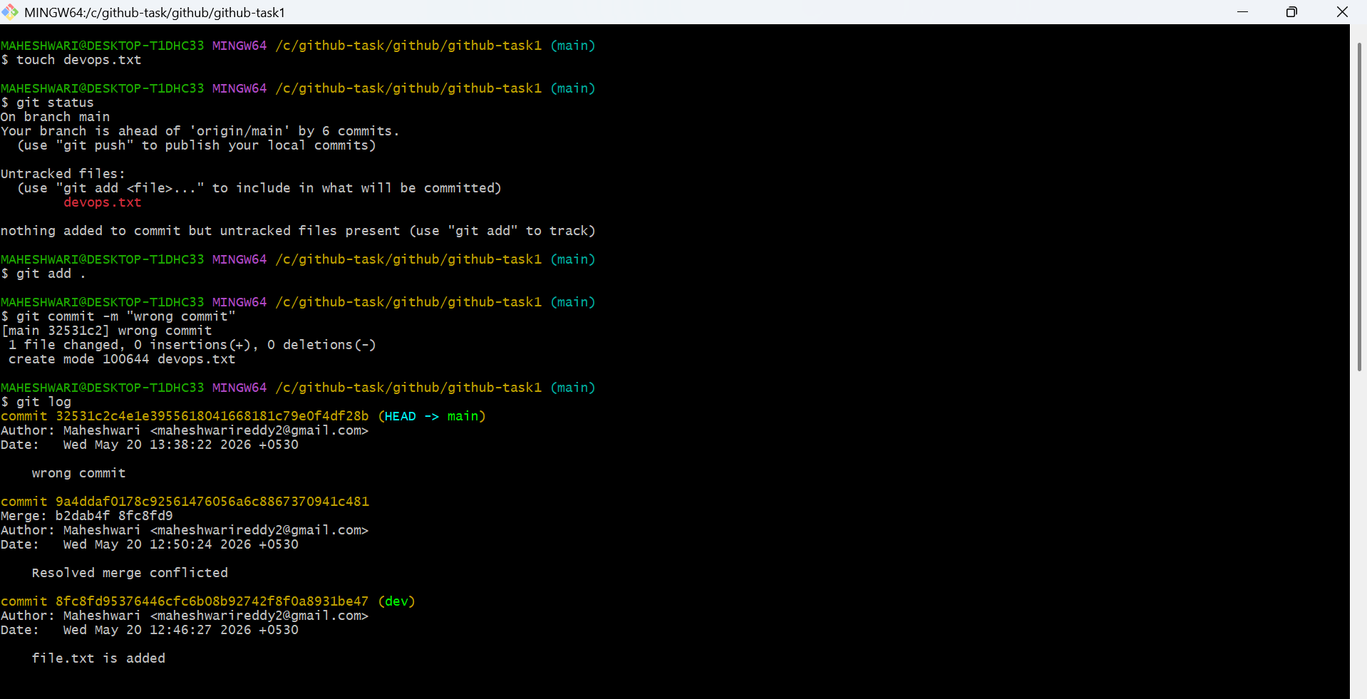
- Then copy the commit id that we want to revert it back
- Then revert the commit by the command -> git revert commitid
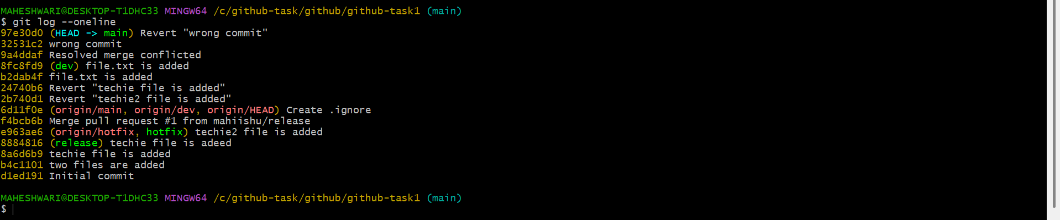
- Then push it to the main branch of github -> git push origin main
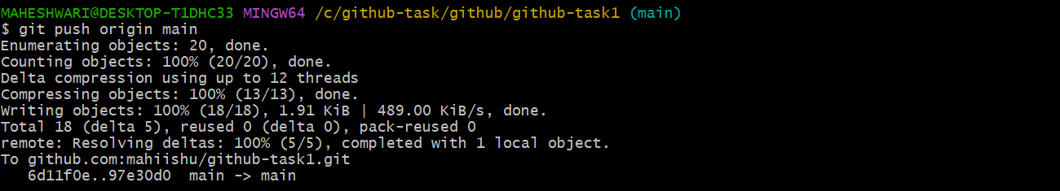
- Amend a Commit
- Initialize a repository -> mkdir amend-demo
- Then get into that repo by using command -> cd amend-demo
- Then create a file -> touch app.txt
- Then add that file from untarcked area to tracked area -> git add .
- Then commit that change -> git commit -m “appt.txt file is added”
- Then added another file -> touch feature.txt
- Add that file and commit that change
- But forget to commit another file so that to commit this we use -> git commit –amend
- By the above command, this will amend the previous commit with the current change
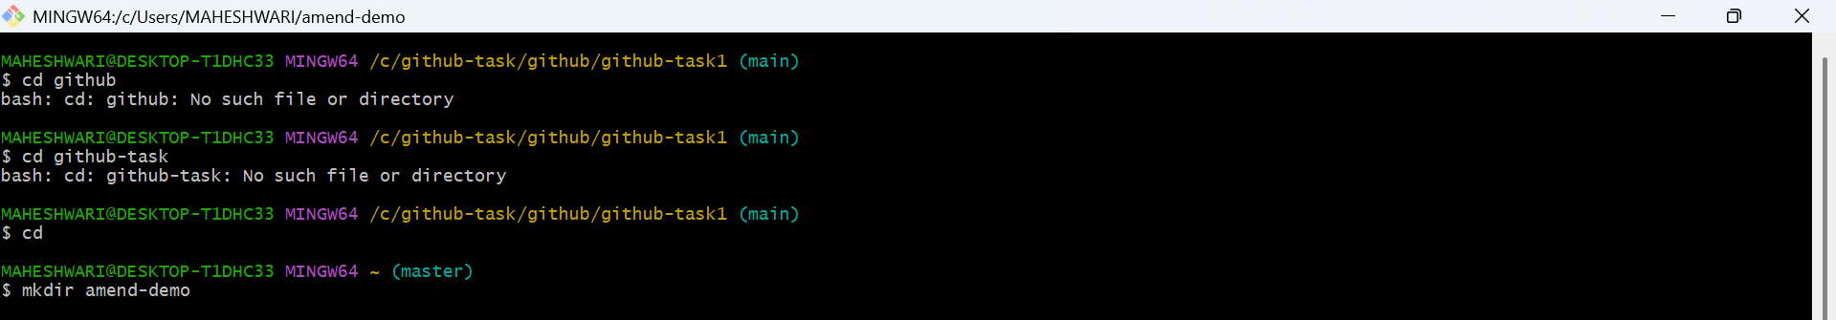

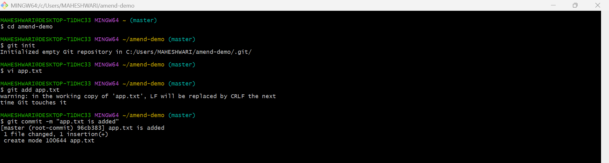

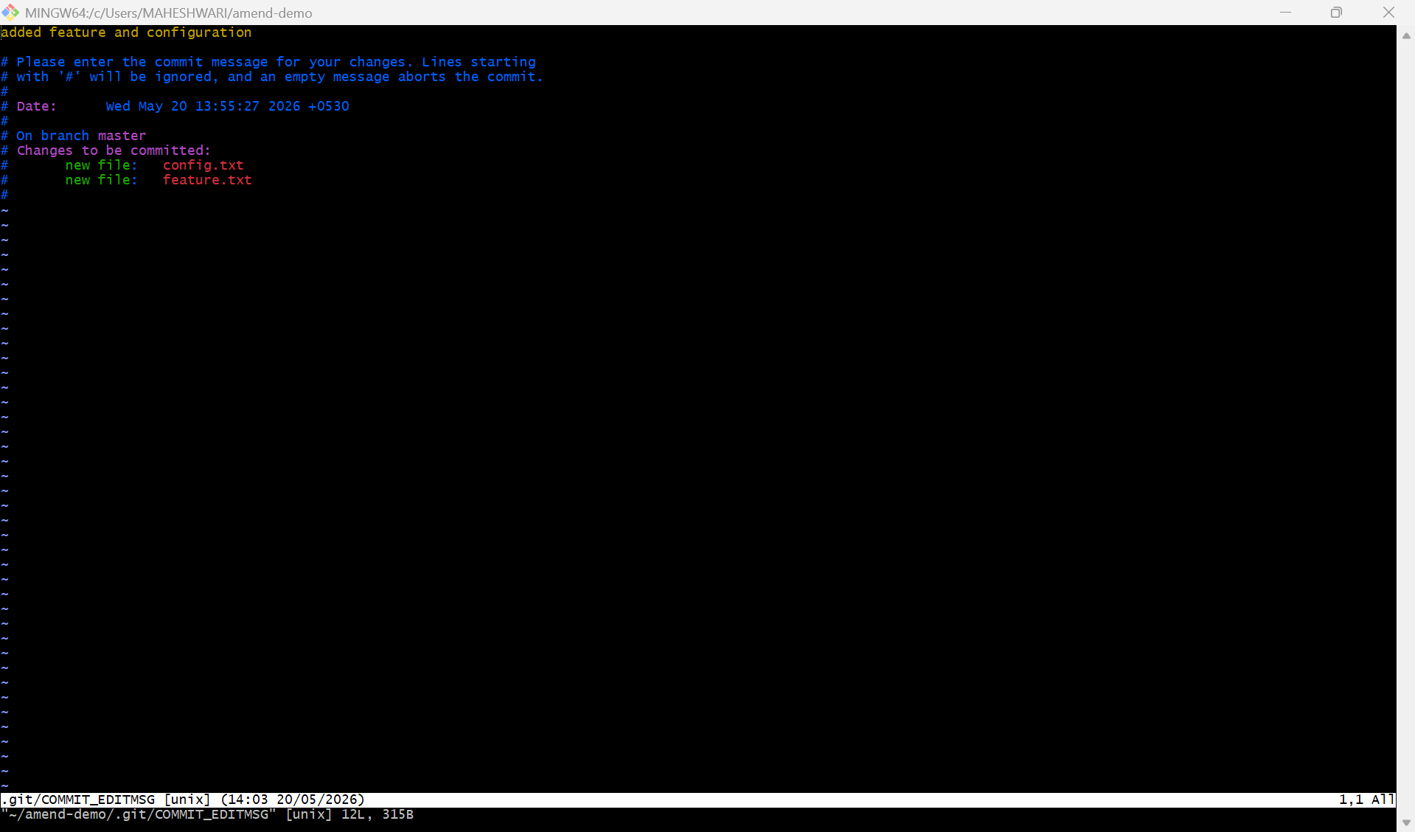
- Cherry-pick a Commit
- Create a new branch called release -> git checkout -b release
- This will switch u from master to release branch
- Here in release branch create a file release.txt -> vi release.txt
- Add this file from untracable area to tracable area -> git add .
- Commit this change -> git commit -m “login implementation”
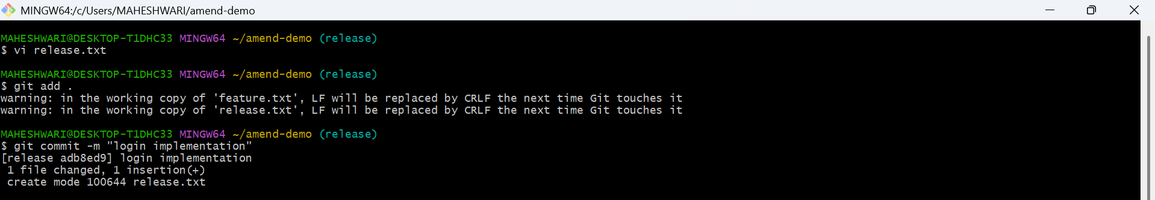
- Then copy the commitid we get the commitid’s with the command -> git log
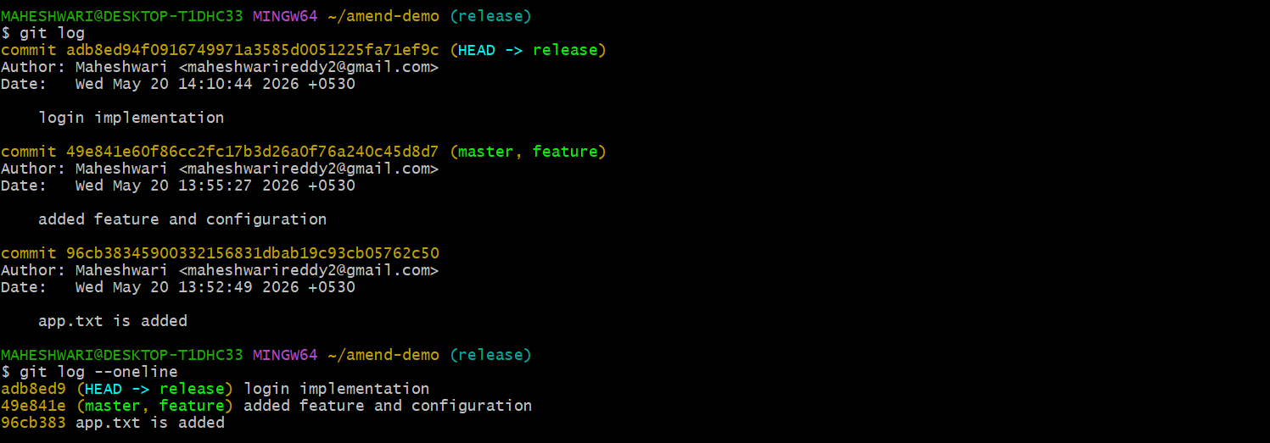
- Then switch to the master branch -> git checkout master
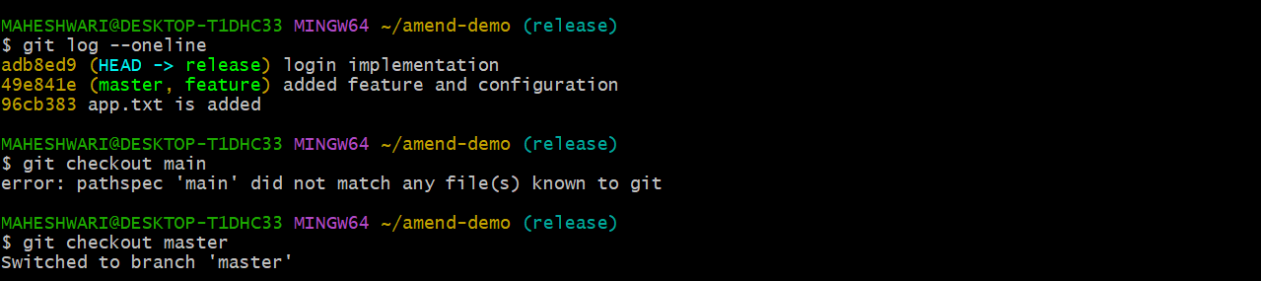
- Use the cherry pick command to have the same commit in the master branch also -> git cherry-pick commitid
- Then u can have the same commit from release from branch in master branch also
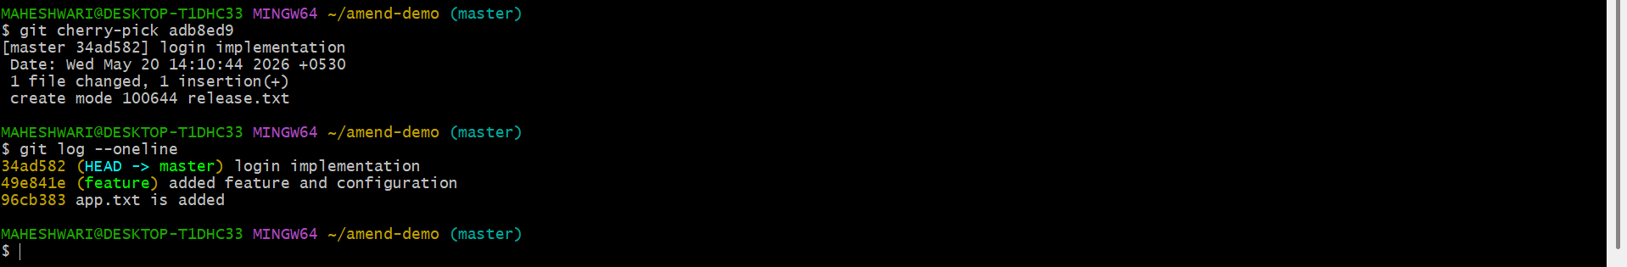

- Interactive Rebase
- Get the log of commits -> git log
- Then squash the commits into single commit -> git rebase -i HEAD~3
- This command will squash 3 commits into single commit
- Replace the pich line with squash
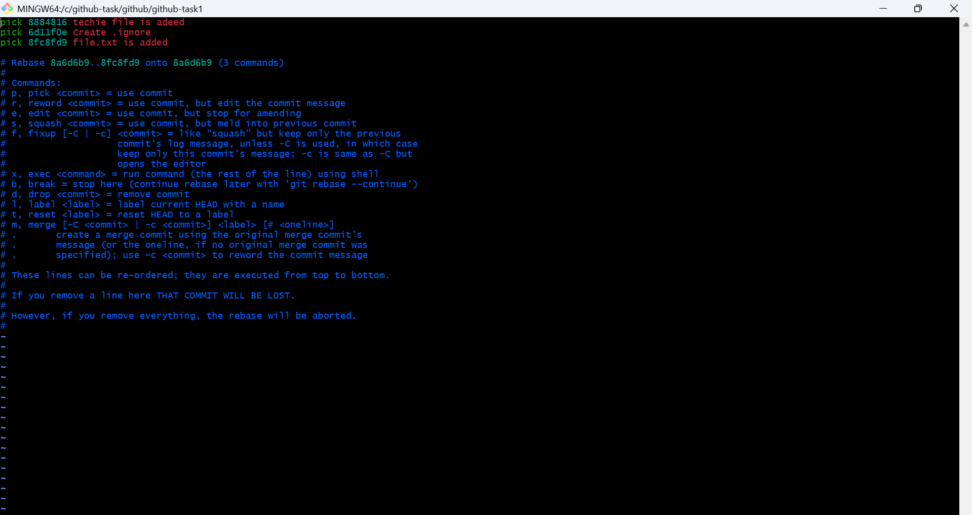

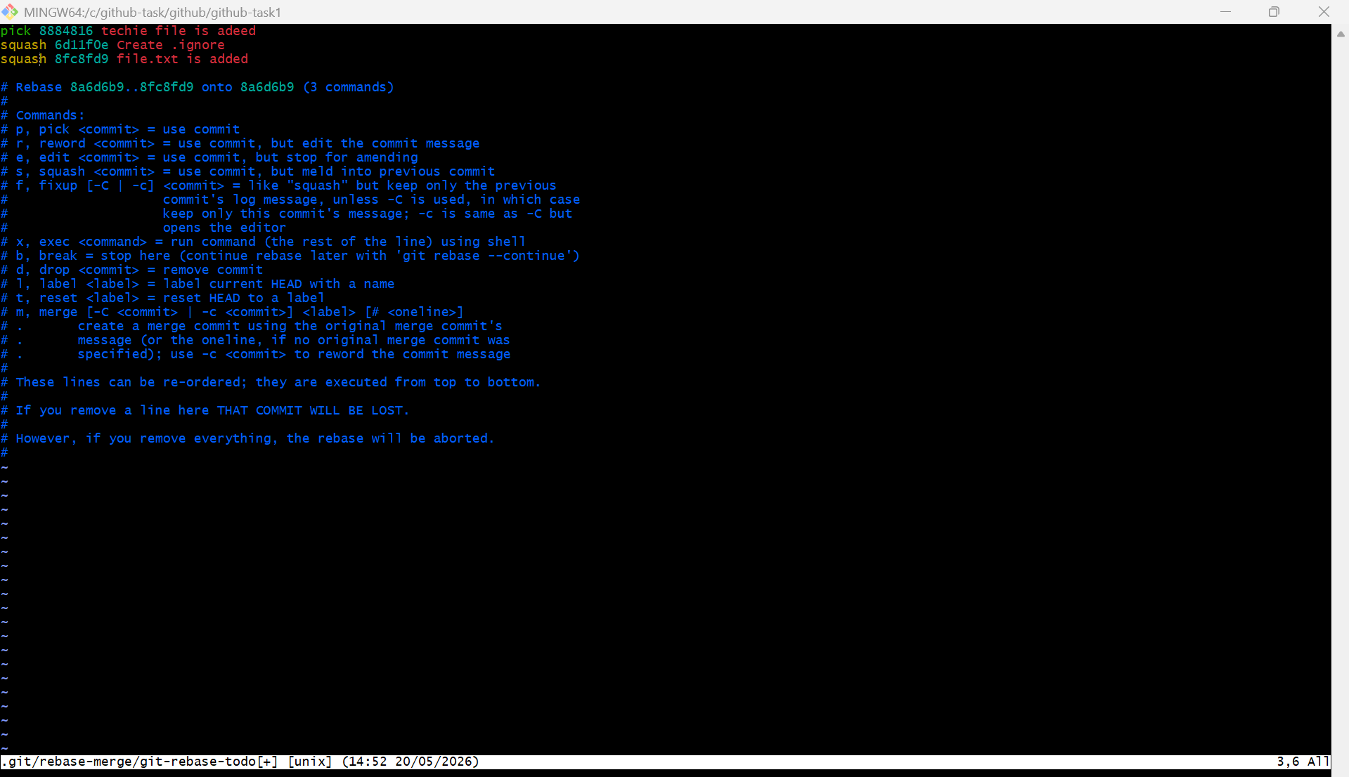

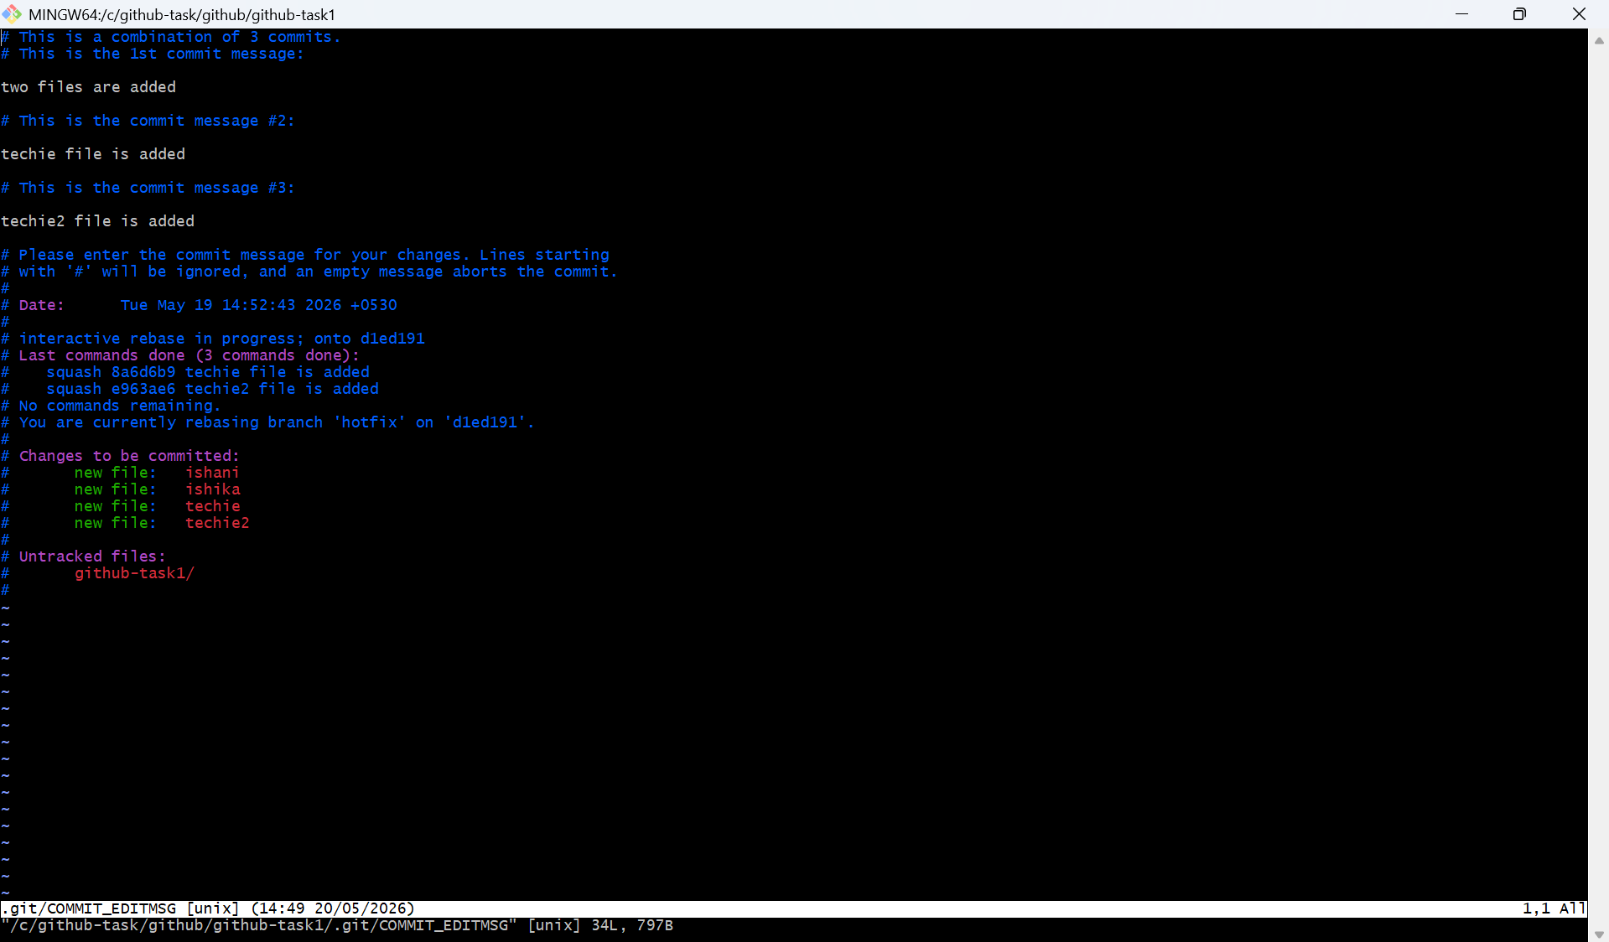

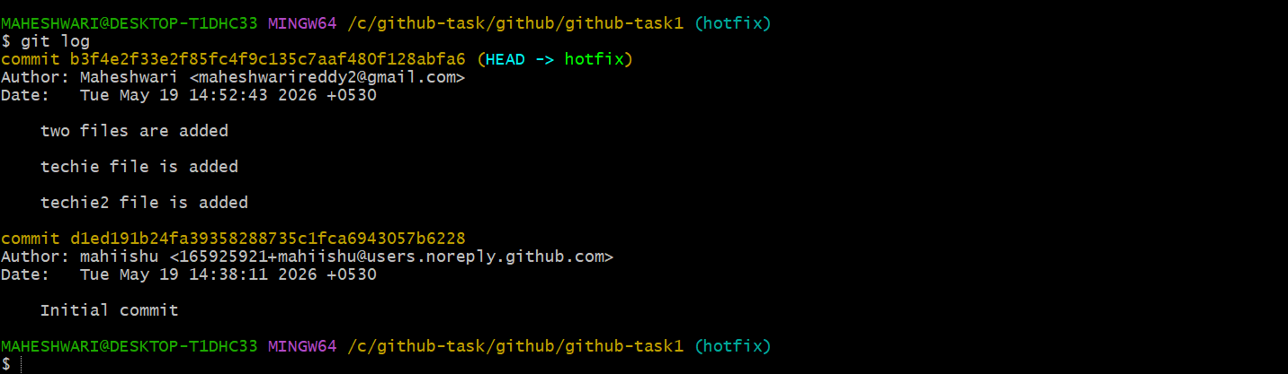

- Tagging & Release

- Firstly check the git log whether we have a commit or not, if not create file and commit it
- Then add a tag by the command -> git tag v1.0 or git tag -a v1.0 -m “version 1.0 tag is added”
- Verity that tag is created or not -> git tag
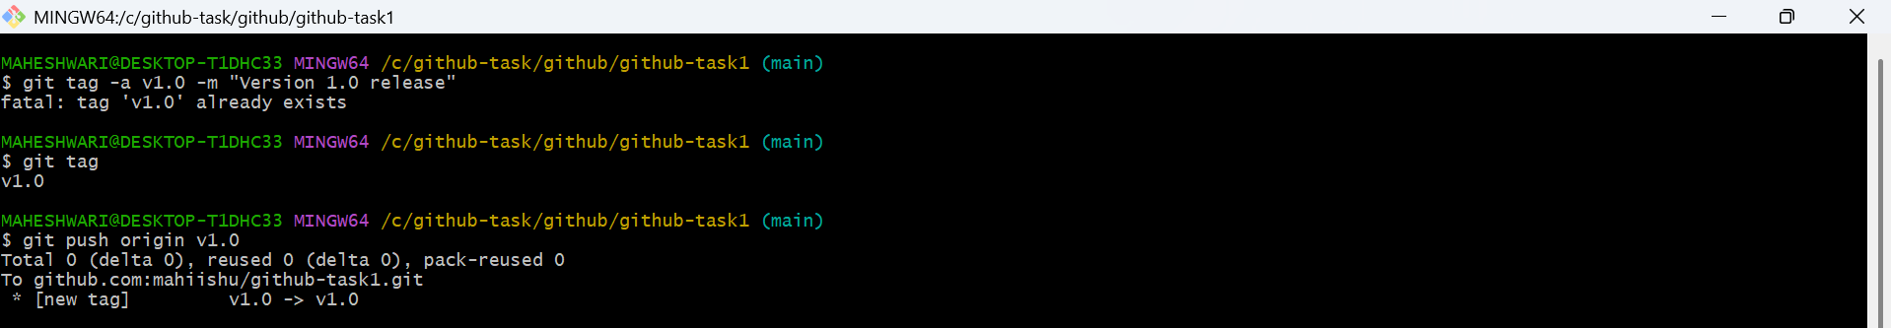
- Then delete it from the local -> git tag -d v1.0
- Delete it from the github -> git push origin -delete v1.0
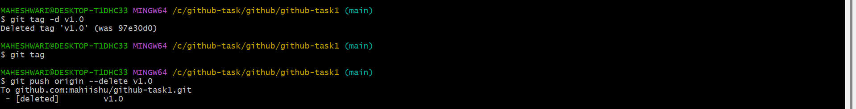
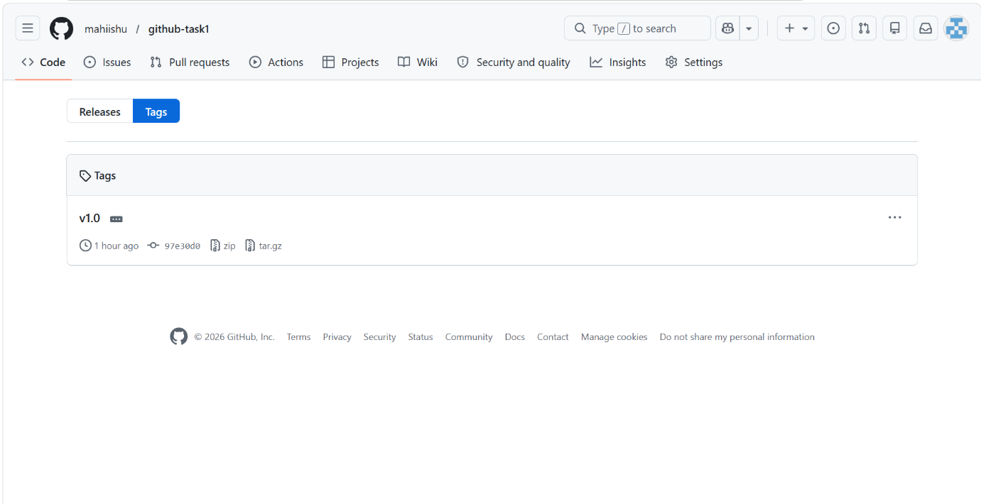

- Restore the deleted tag by the commit id -> git tag -a v1.0 <commit-id> -m “restored tag v1.0”
- Verify the tag again -> git tag
- Git push origin tag -> this will push the tag to the github account
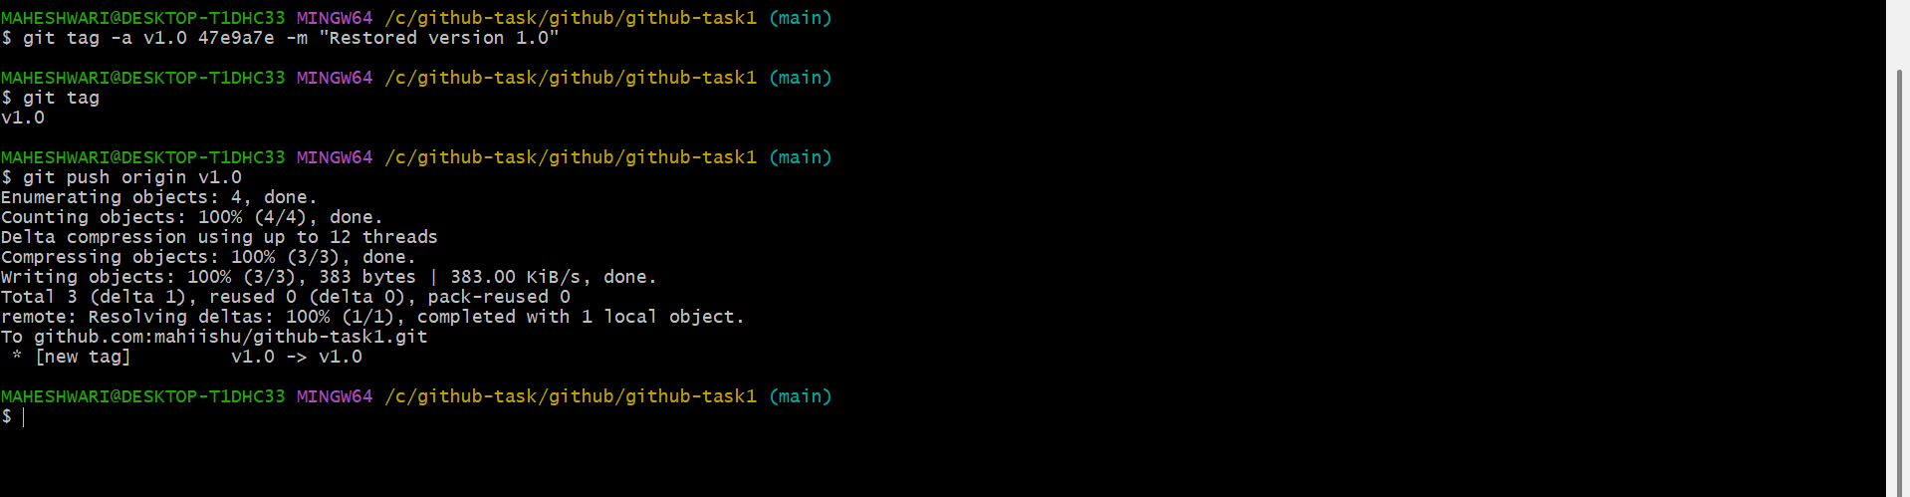

- Clone with Sparse Checkout
- Create a repo in github and clone it to our local machine
- Clone the repo without the files -> git clone –filter=blob:none –sparse <repo-url>
- Then git sparse-checkout the created file in github -> git sparse-checkout set sparse.txt
- Then to verify that -> git sparse-checkout list
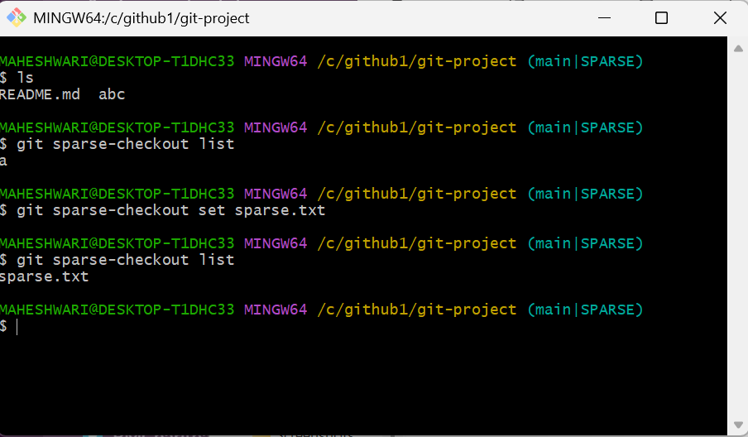

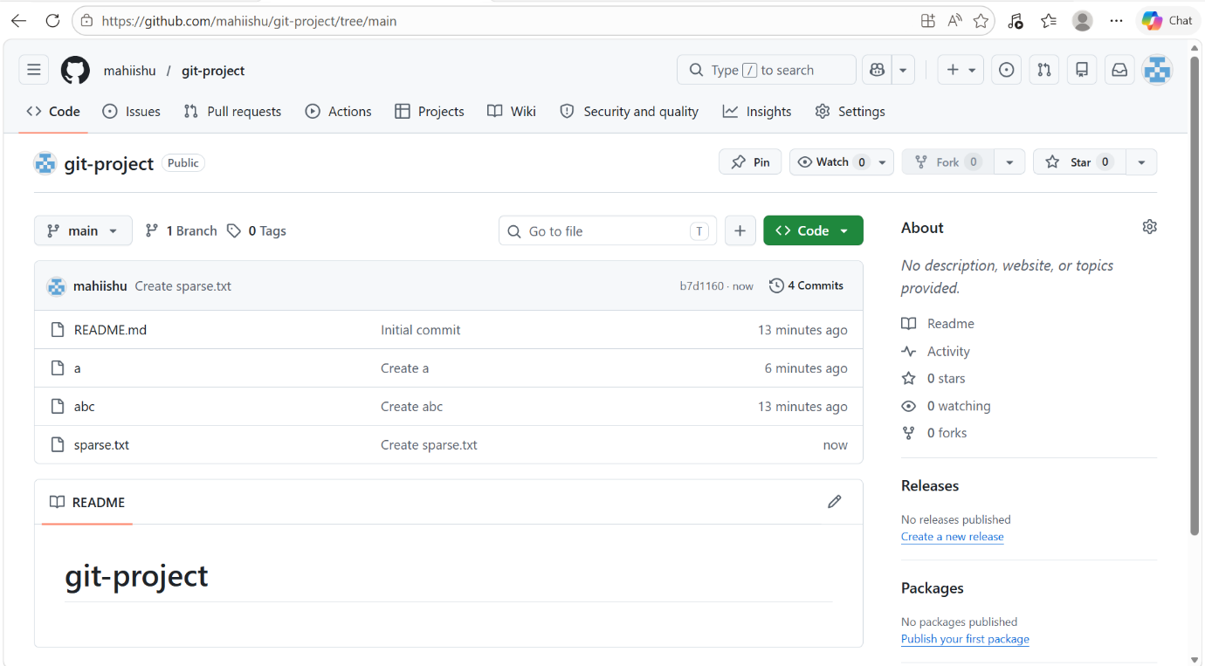

- Reset vs Revert Challenge
- git reset –hard -> this command will directly deletes the last commit
- git revert HEAD -> this command reverts the commit to the head position
- add versions of updated in a file app.txt by append (>>)
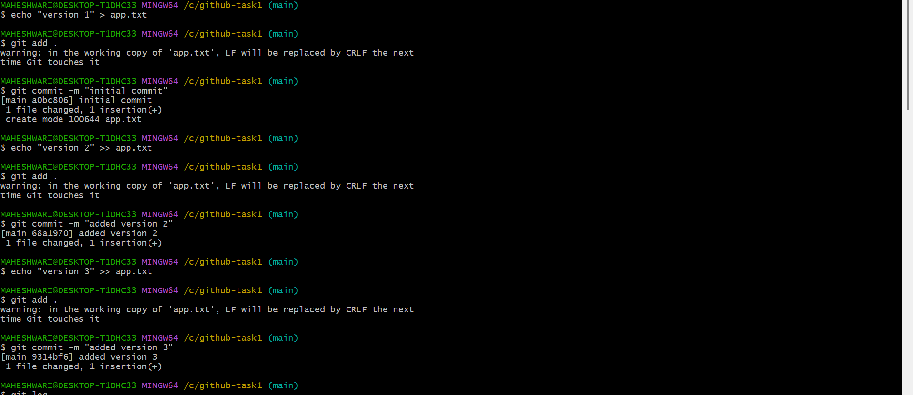

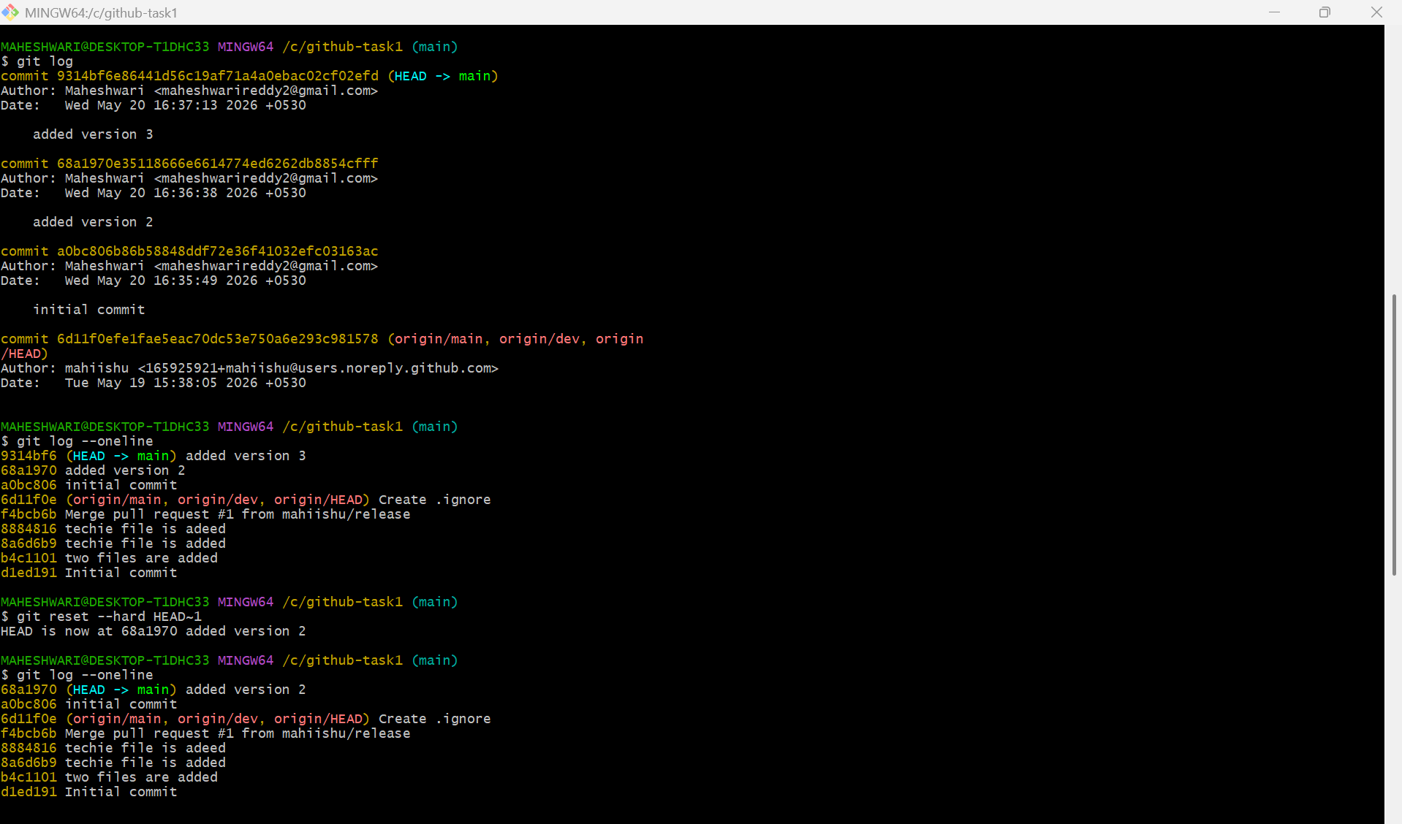

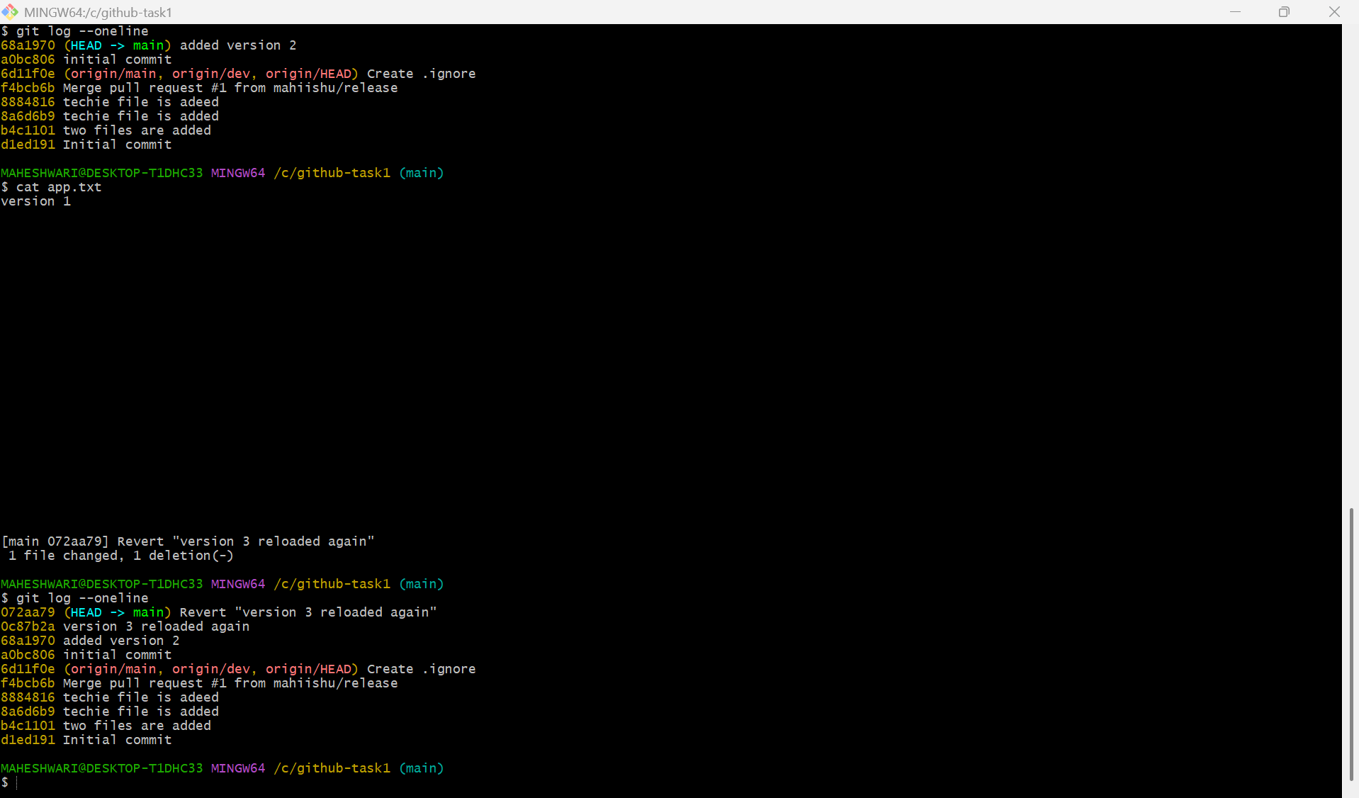

10.Detached HEAD Challenge
- detached HEAD state means that head is pointing directly to a commit instead of a branch.
- This can happen when you check out a specific commit or tag directly, or when you are in the middle of a rebase or cherry-pick operation.
- In this state, any new commits you make are not part of any branch unless you explicitly save them.
- Its important to create a new branch before making changes in a detached HEAD state to ensure your work is saved and not lost.
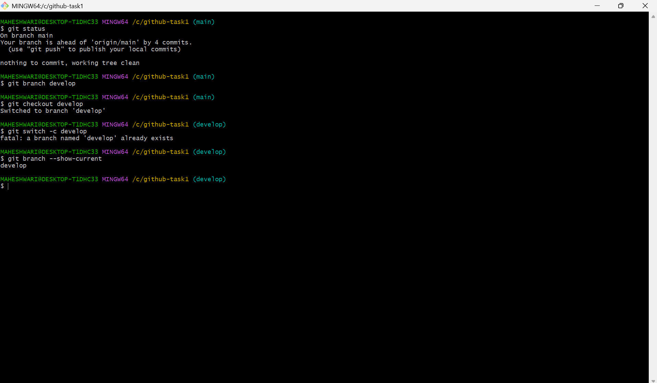

11.Git Hooks Challenge
- Firstly go to .git/hooks directory -> cd /git/hooks
- Then create a file commit-msg -> touch commit-msg
- Edit the file with the pre-commit configuration
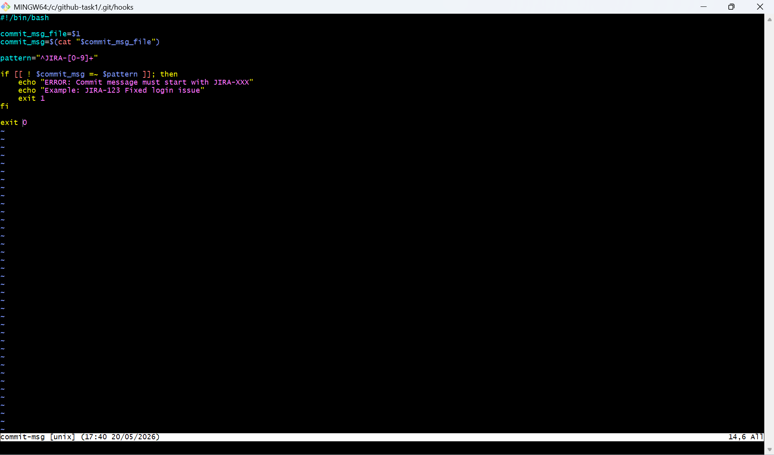
- Then change/modify the permissions to make that file to be executable -> chmod +x commit-msg
- Then get out of the /git/hooks path
- Then create a file and add that file
- Then commit that change
- Here, you can see the error
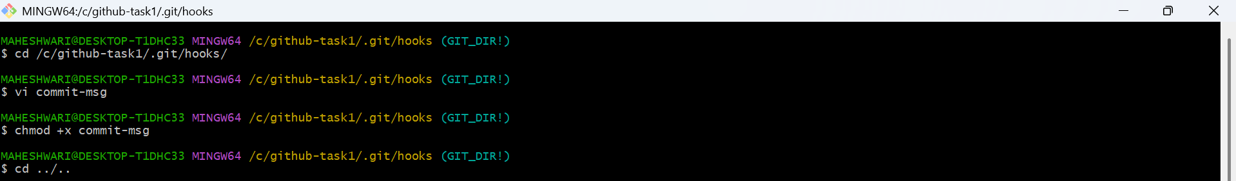
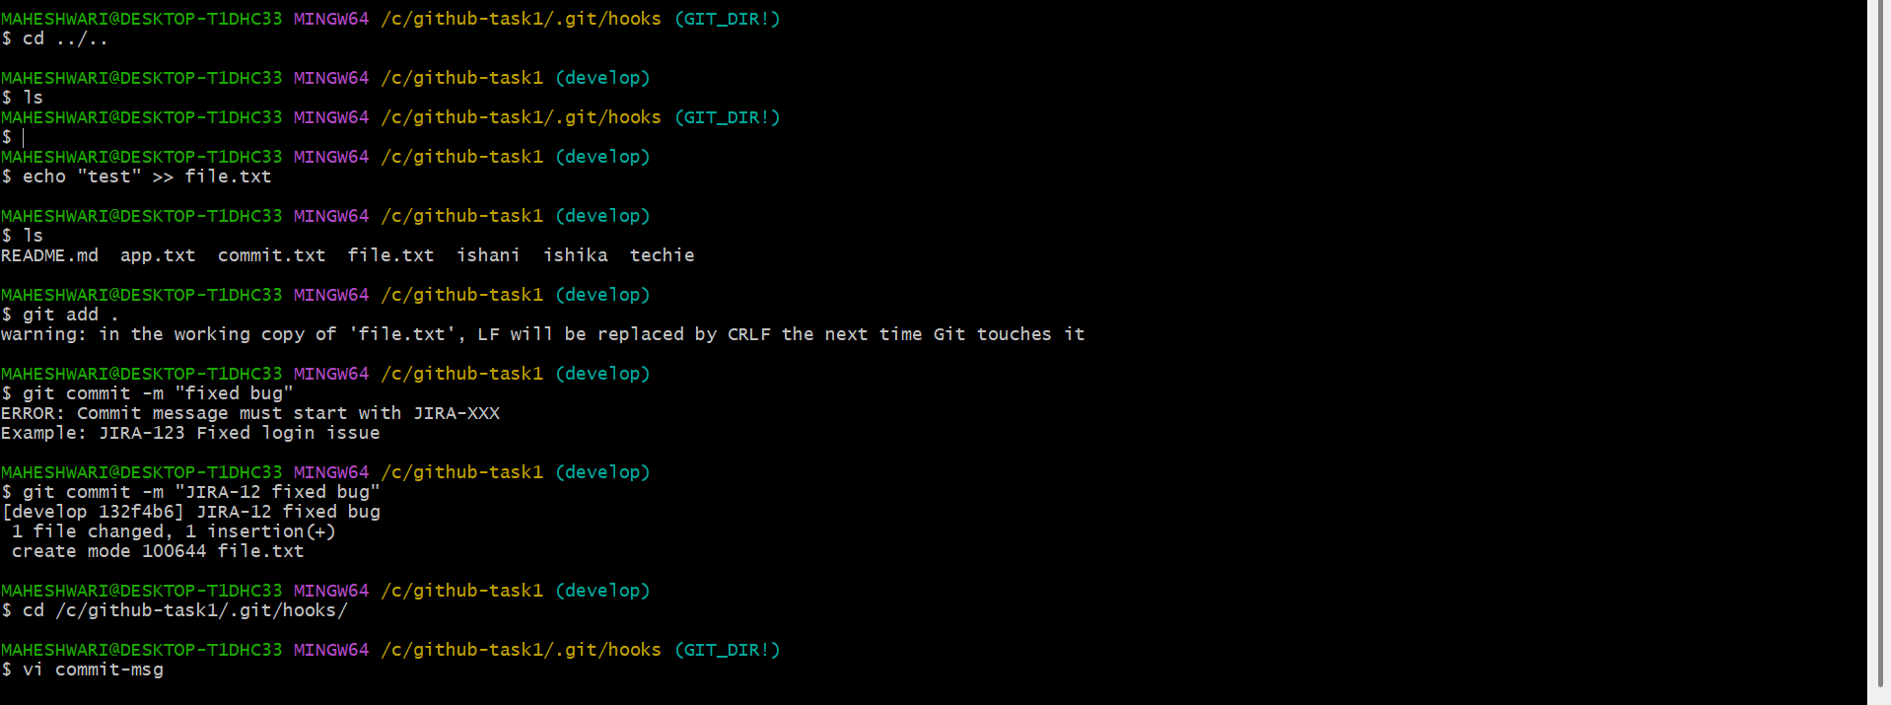

12. Squash Merge vs Rebase Merge
- Squash merge:
- Squash merge will combine all commits into single commit
- By using this merge, we can maintain clean history
- It is good for pull requests
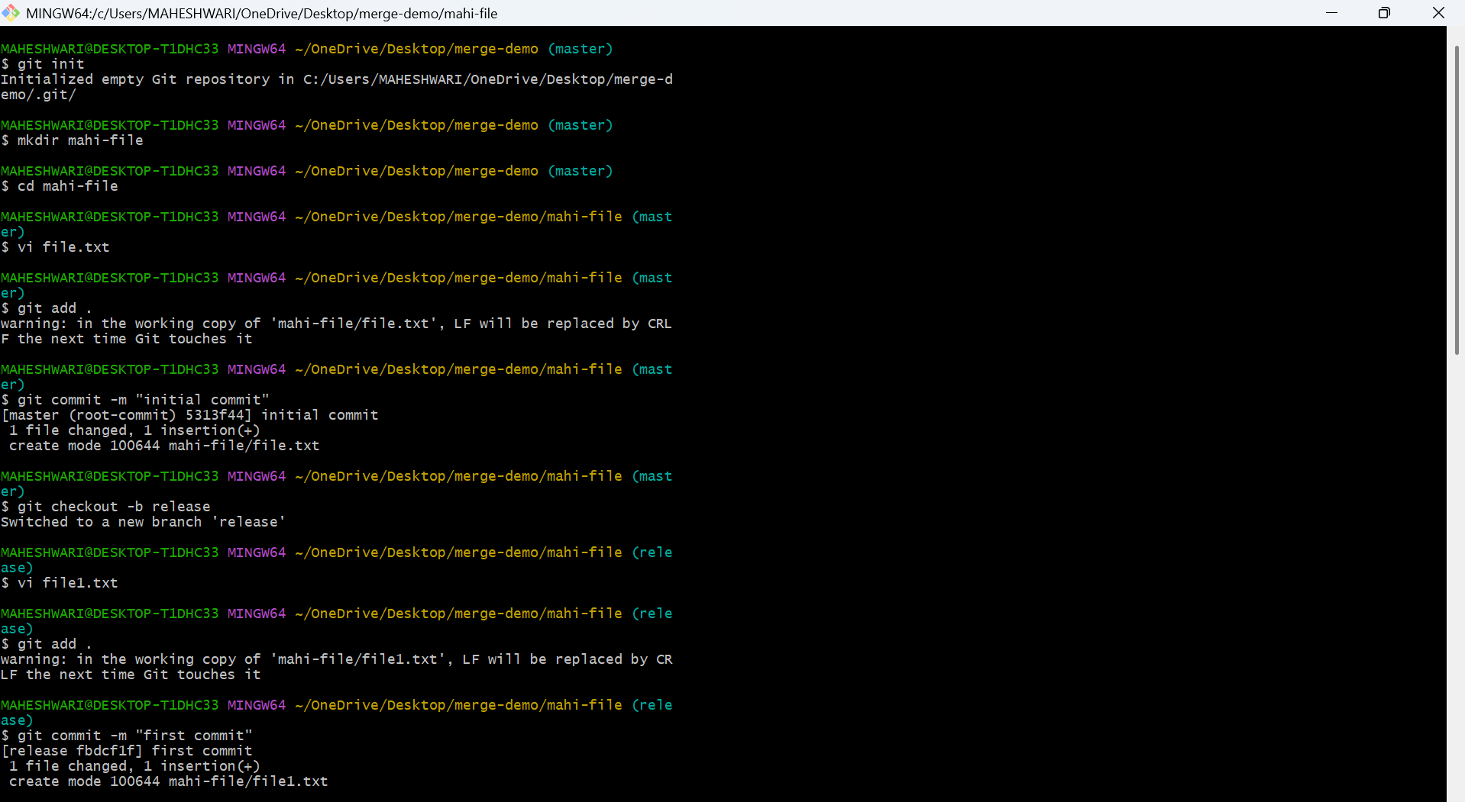

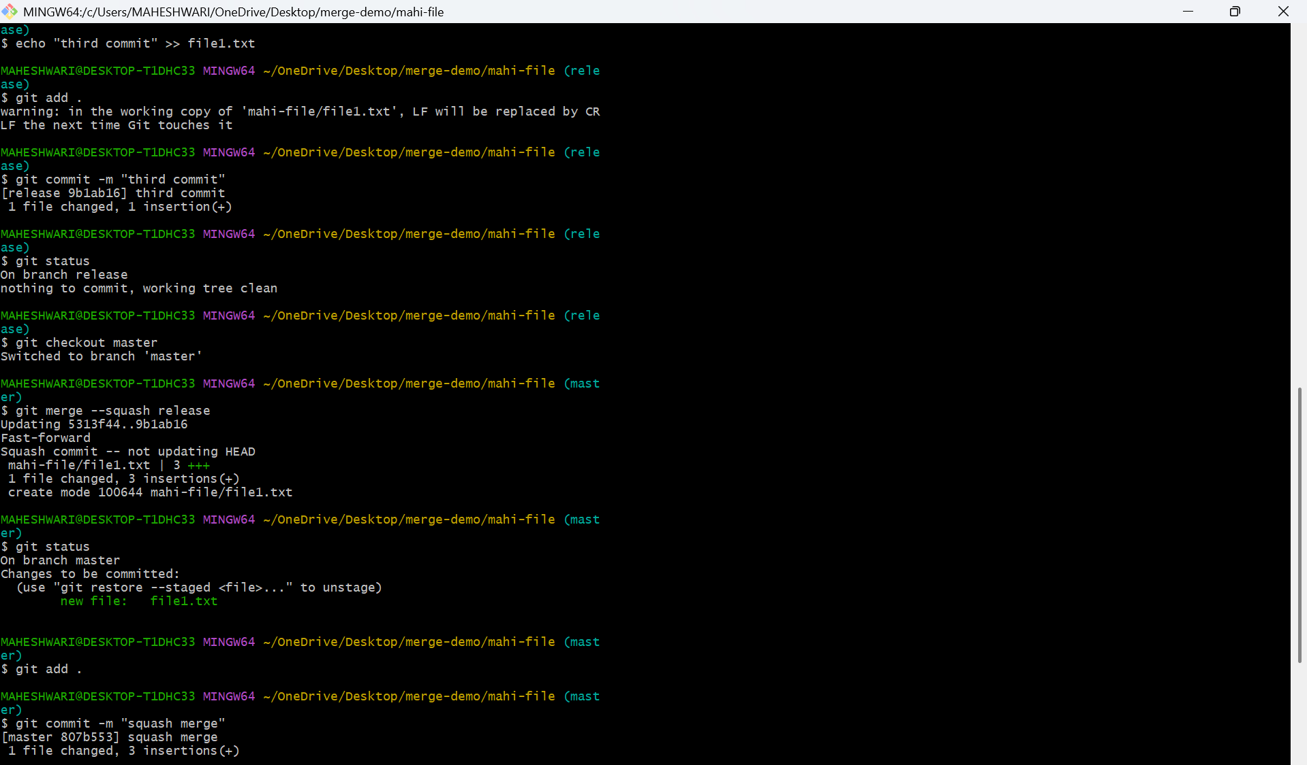

- Rebase merge
- Rebase merge is also same as squash merge but it shows the every commit step by step manner
- It is usefull to make commit history safe
- Syntax -> git rebase -i HEAD~3
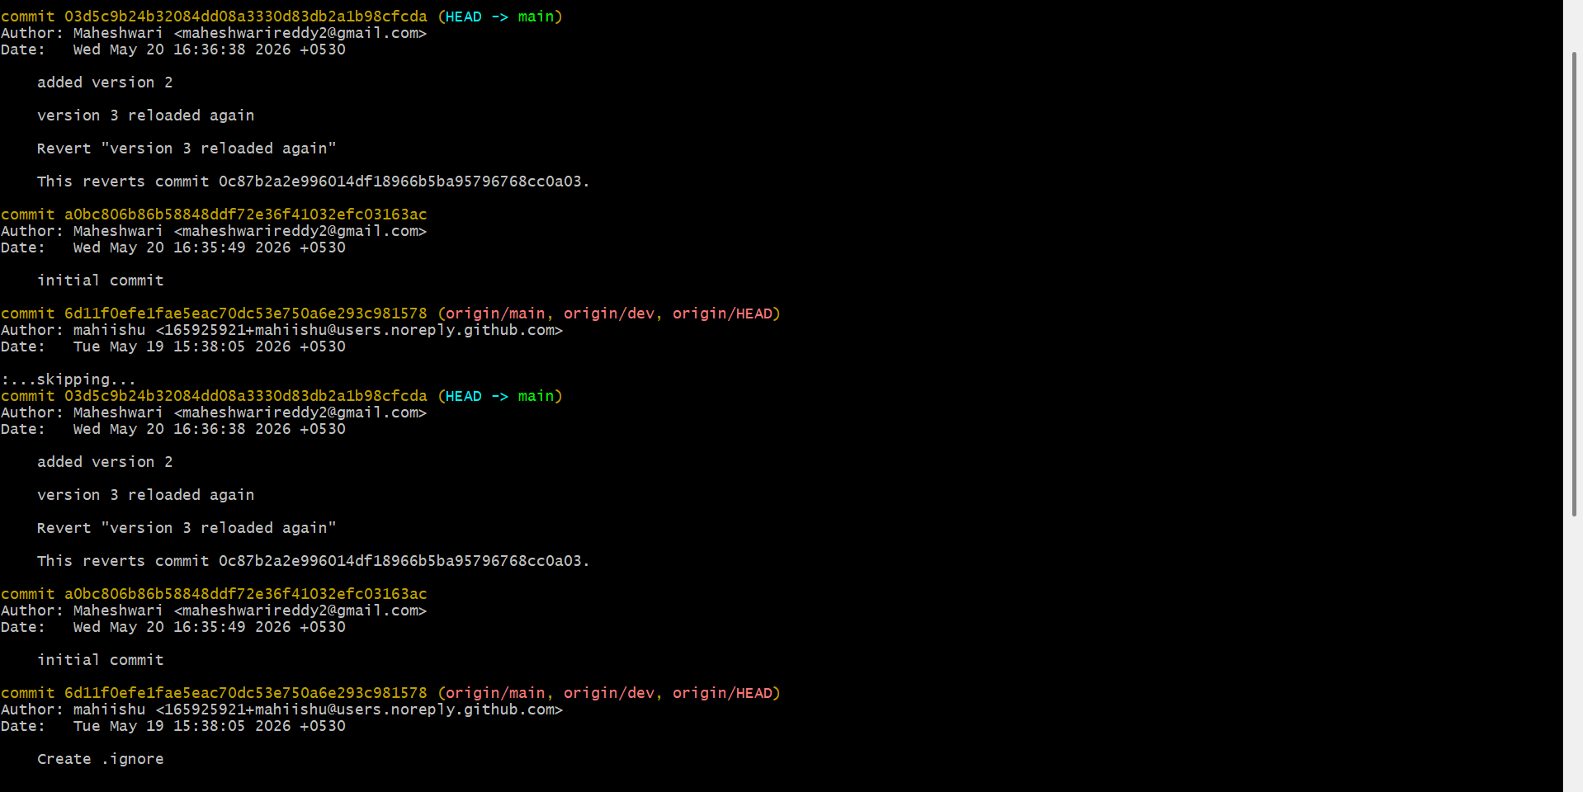

13. Fork & Pull Request Workflow
- Create a fork of a repo from another account
- Then create your own fork with unique name
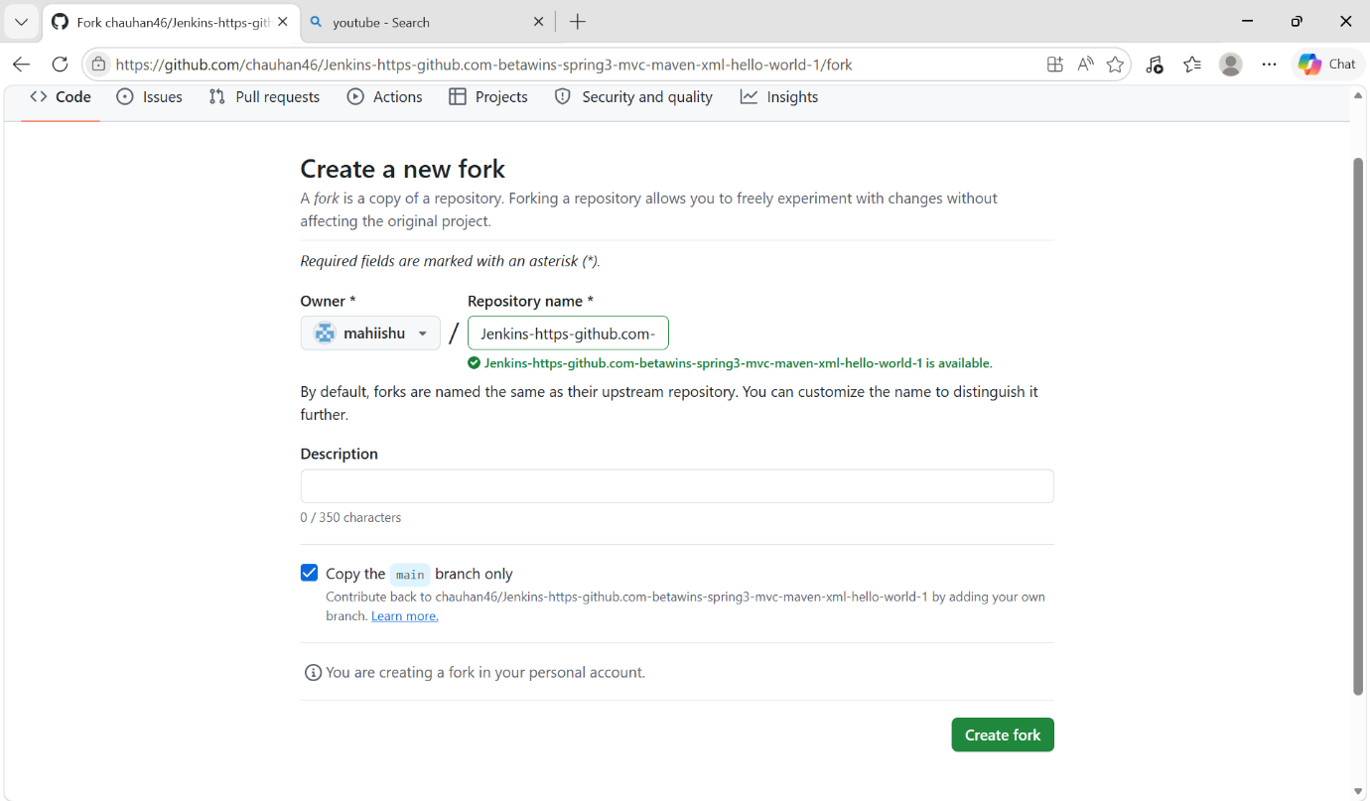
- Am using sparse to download only one directory
- To initialize sparse -> git sparse-checkout init
- Then using set command we can pull only one directory which u want -> git sparse-checkout set Jenkins-file
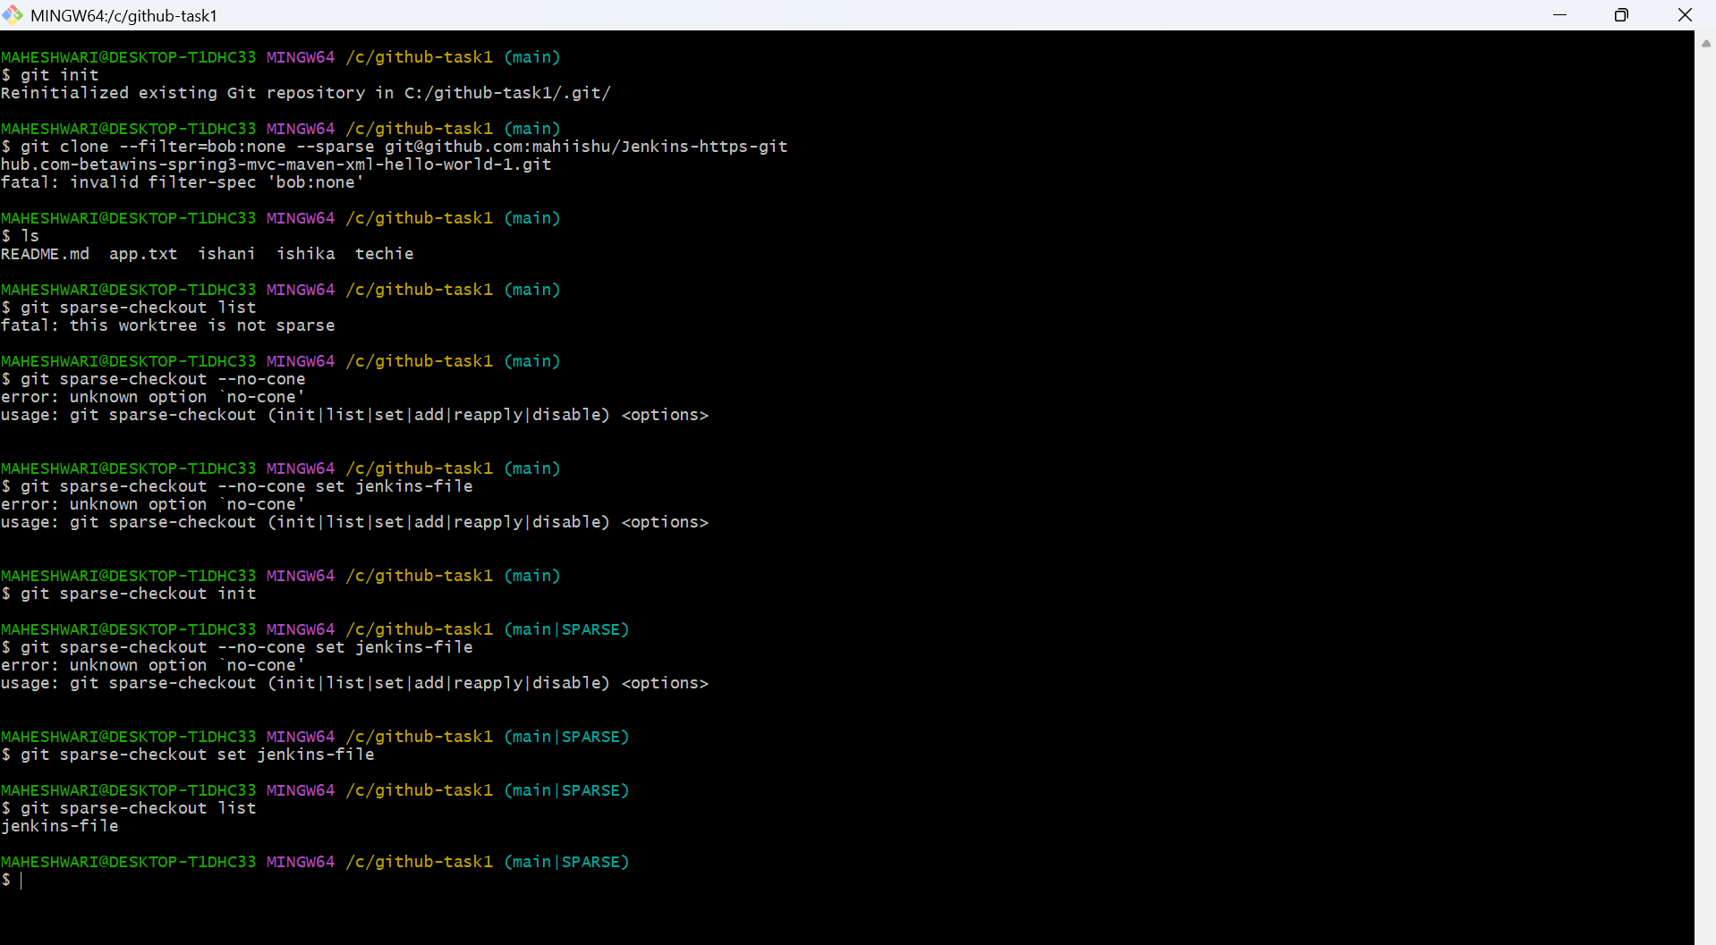

14. Recover Lost Commit
- Using rebase the recently commited commit will delete and replaces the HEAD with the given commit id
- To revert this commit, again give the commit id of recently modified commit.
- It will regain the last commit
